Title: Performance Analysis of Brain Control Interface in Drone Applications

Publisher: the ACMSE 2018 Conference

Date of publication: March 2018

Author:

Sarah North, Ahmad Alissa, Josh Cooper, Adnan Rashied, Eric Rawls, Jason Walters, Utku “Victor” Sahin, Kade Randell and Cheyenne Sancho

Review:

The purpose of this study was to investigate the innovative usages for a brain-controlled drone and how effective these drones might operate. This study also tested the bounds of human connectivity with a mind-controlled drone and also to find efficient methods to utilize brain control interface in conjunction with aerial drones. The study investigates how effective the EPOC+ is by challenging users of diverse genders and ages to complete tasks using mental commands or facial expressions to control a Parrot AR-Drone 2.0. After a mental and facial commands calibration phase, the designed experiments were conducted using randomly selected participants (n=20). .

Apparatus:

The experiments used an array of laptops and other electronic devices, but our main assessments were completed with the EPOC+, designed by Emotiv, and the Parrot AR-Drone 2.0.A dedicated laptop was used to display and collect the assessment results in real-time.

Methodology:

**Participants**

Twenty participants (n=20) both male and female, ten (10) male and ten (10) female, with ages equal or greater than to eighteen (18) participated in the experiments. Participants were randomly selected.

**Procedure**

The first initial step was the nodes that allowed the connection from the EPOC+ device were soaked in multipurpose solution and connected to the device. The next step is to make certain each node is receiving a good connection. This was determined by viewing the user interface and making sure the nodes were displaying as green color signal on the screen. A black, yellow, or red colored node meant the connection needed to be reevaluated. Once a proper connection was established, the EPOC+ was calibrated. Calibration occurred by connecting the EPOC+ to the Xavier Composer interface). The user then was subjected to the “virtual cube experiment,” which was the first stage of testing; during which, the user followed a set of commands where they imagined moving the virtual cube with their mind in a specific order. For example, the user was prompted to “push, pull, lift, shift to the right, shift to the left, and lower” the virtual cube. During the next part of experiment, the EPOC+ was connected to the Parrot AR-Drone 2.0. The user then attempted to replicate the results from the virtual cube experiment; only this time with an actual tangible object: the Parrot AR-Drone 2.0. The following stage of experiment was completed in the same manner as the preceding experiment. The next phase was completed with facial commands. The participant then used facial movements such as blink, smile, and clinch to make the drone perform certain movements.

Results:

Despite some connectivity issues, a good number of participants managed to fly the drone using the facial commands while a slightly smaller number of subjects could manipulate the drone with mental commands once it was in the air. Females tended to have better control over both the virtual cube experiment in the MindDrone App and controlling the drone using the EPOC+ headset. The male subjects consistently succeeded in passing the ‘virtual cube experiment’ but could not translate the thought control into manipulating the drone. There is no significant difference in difficulty between the user’s ability to control the drone using mental or facial commands utilizing brain control interface in conjunction with aerial drones.

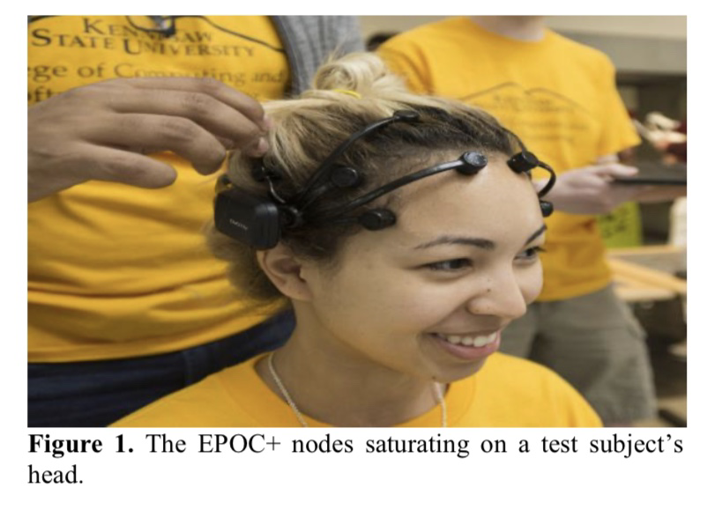

Advantage:

This technology can make the user feel more immersed than other technology can such as a keyboard, mouse, controller, or any other device.

Disadvantage:

1. Individuals had greater difficulty controlling the mental and facial commands than they originally expected.
2. Allowing for some trouble with the hardware, the toughest part of running the experiment was providing consistent connection between the computer and the drone

Scope of improvement:

There is no significant difference between the rating of difficulty before and after between the mental and facial commands. It is entirely likely that with additional future research, more in- depth details, into what the impacts the level of difficulty in mental and facial commands.

Theory in further research:

In Anderson & McOwan’s [2] summary article reviews an extensive research of Emotiv EPOC+ headset and the correlation on emotions reveals that emotions play an important role in the interactions between humans. Human emotion is fundamental to human experience. Therefore, the study of emotion and the Emotiv neuroheadset is crucial. . The article “Emotion Recognition Using Emotiv EPOC+ Device” was to find the relationship between electroencephalogram (EEG) signals and human emotions. The study’s primary focus was on emotion recognition experiments that are conducted using the commercial Emotiv EPOC+ headset to record EEG signals while watching a variation of emotional movies such this experiments are conducted for further result.